**Assignment 1: Colorizing Images**

* Show at least 3 colorizations with and without alignment.

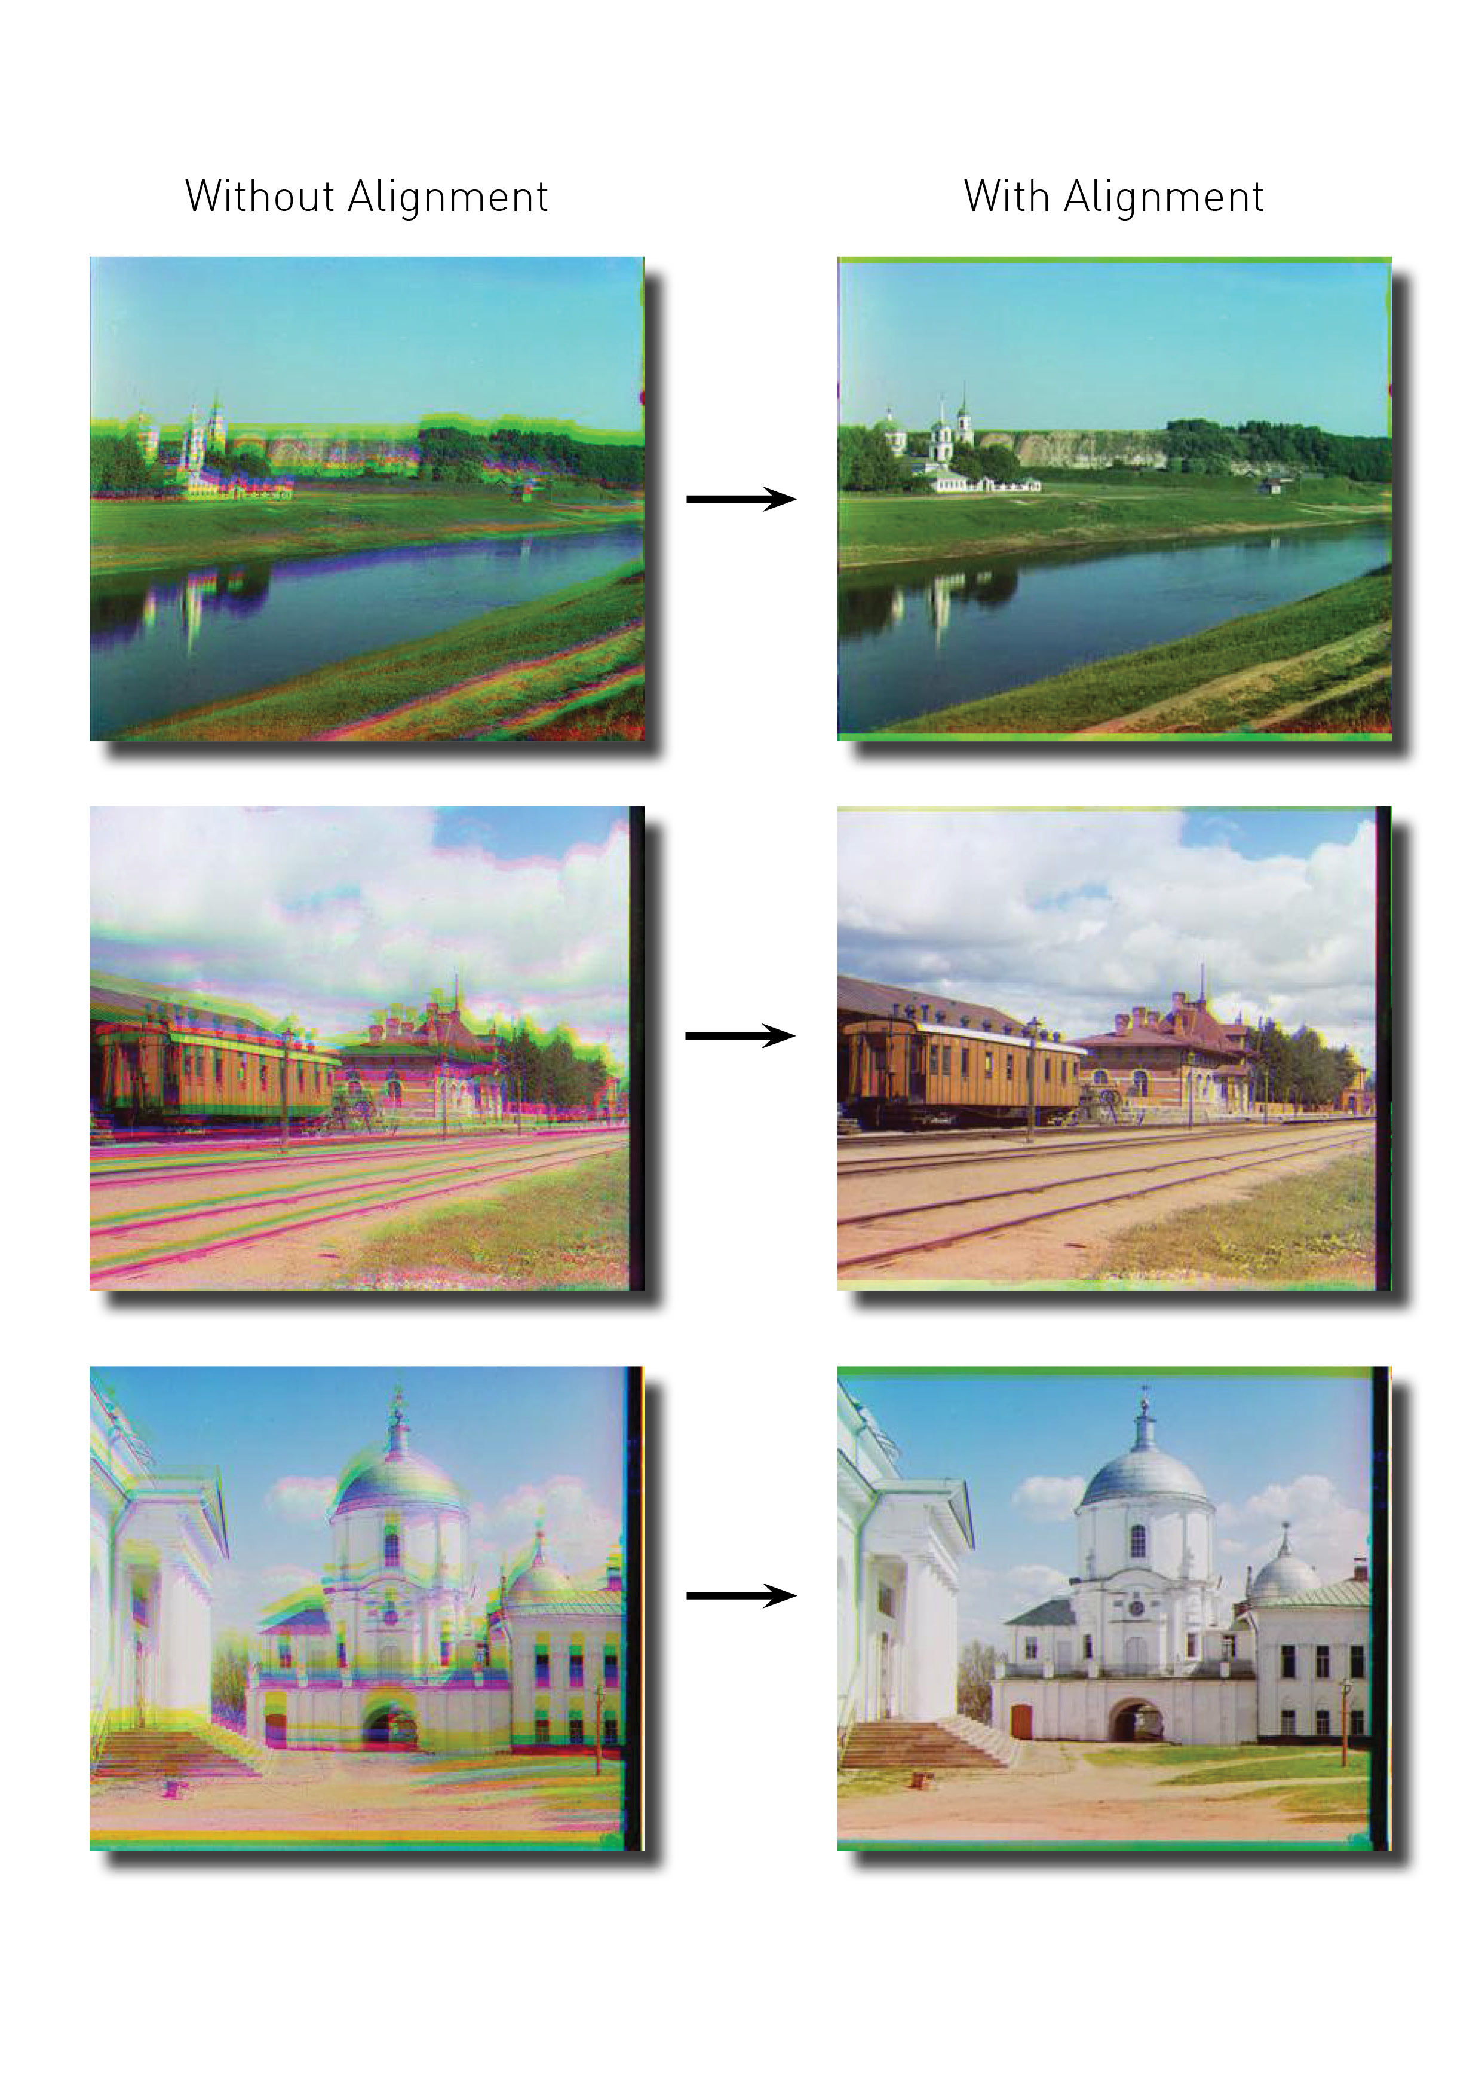

* For the bonus task, show at least 3 high resolution colorizations
* For the bonus task, compare the actual runtime of the original implementation with that of the improved one.

